5/11/2023

Admin

Hewlett-Packard

MySQL Assignment

Umair Rasheed

Table of Contents

Task 12

Task 27

Task 39

EER Diagram11

Individual Queries17

Task 1:

Query 1:

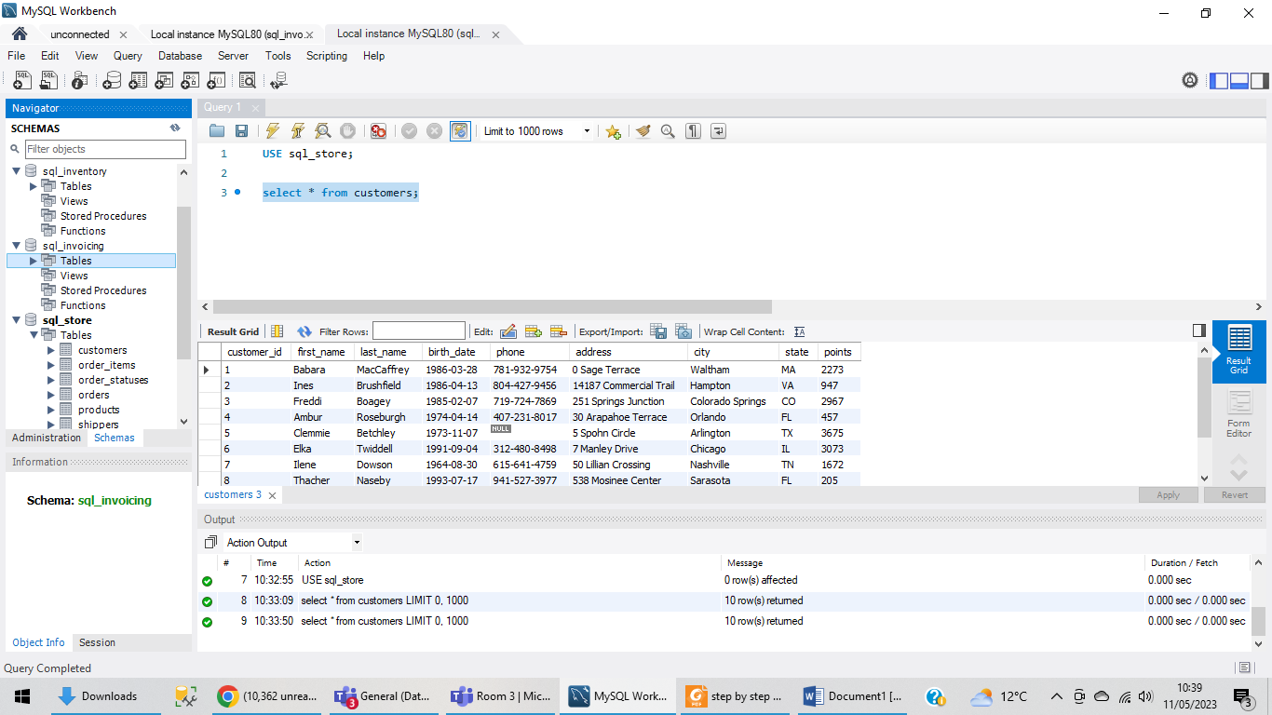

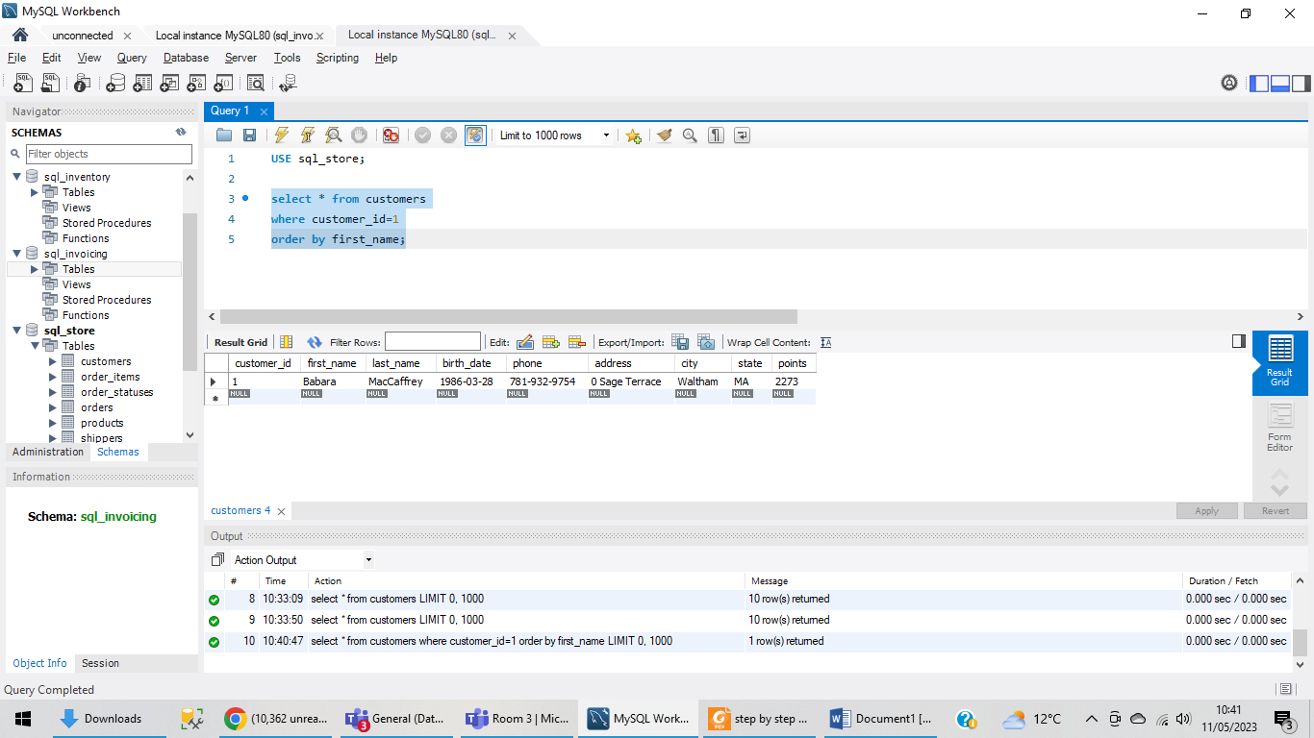

Query 2:

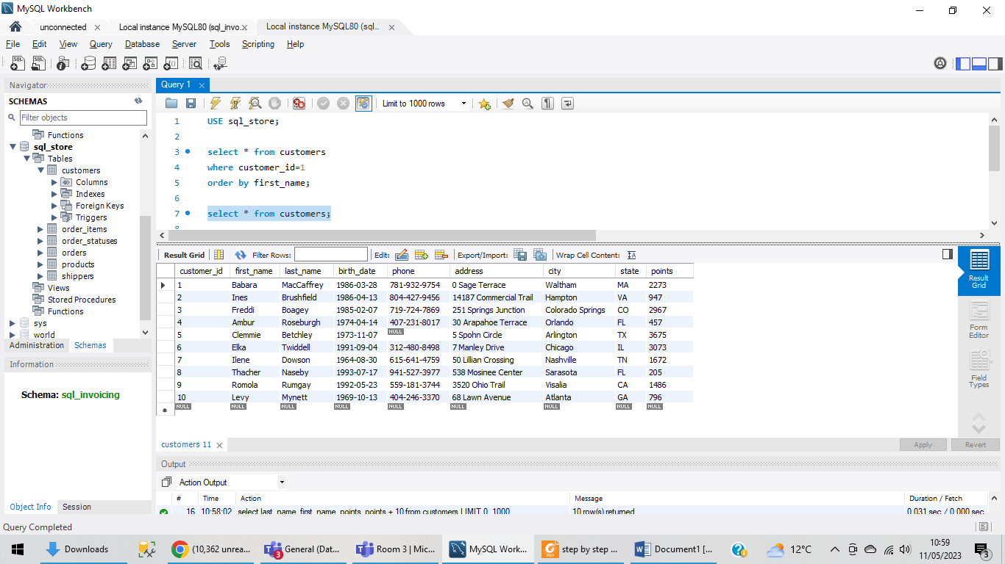

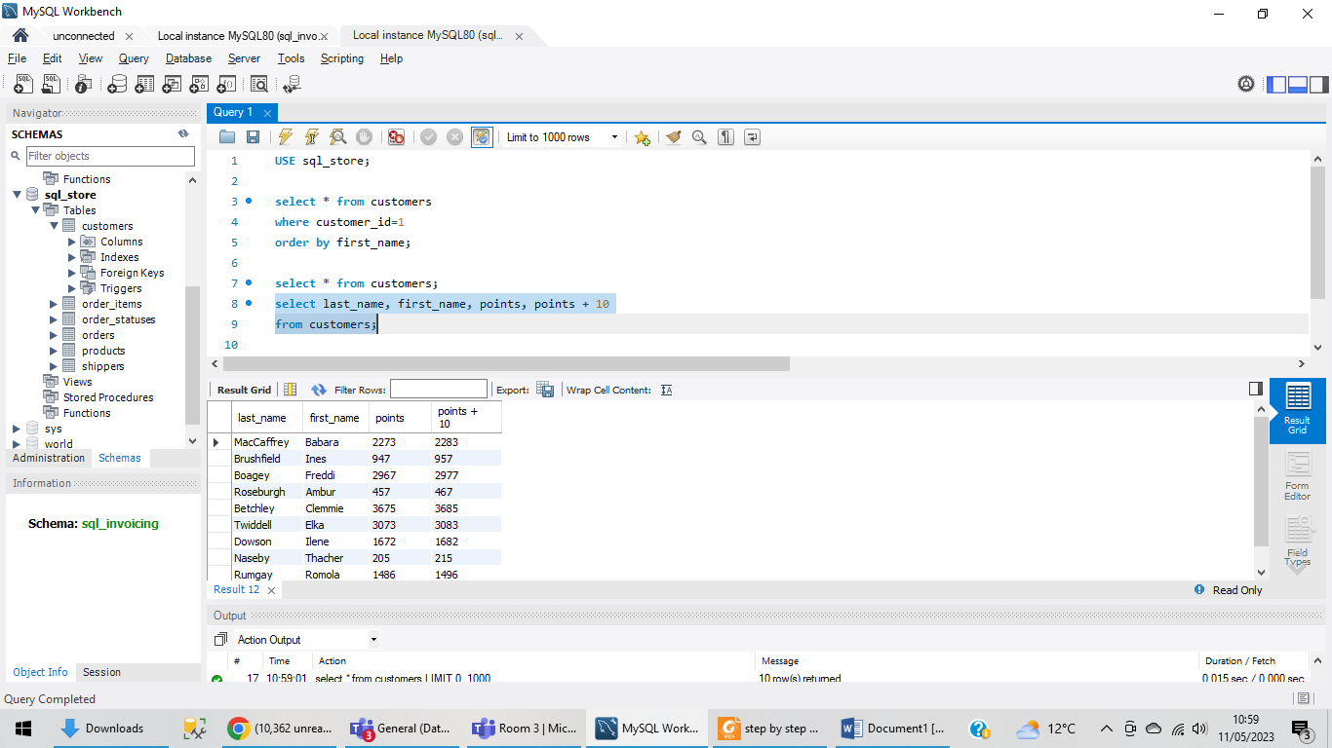

Using the Query 2 you created change the points to reads times by 10 and  
plus 100. Record your results in your word document.

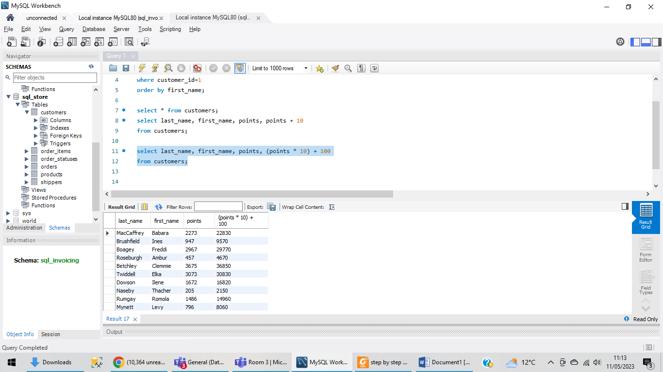

Change the Query 2 code to create a discount factor so the table now  
shows a discount header and changing the (point + 10) *100

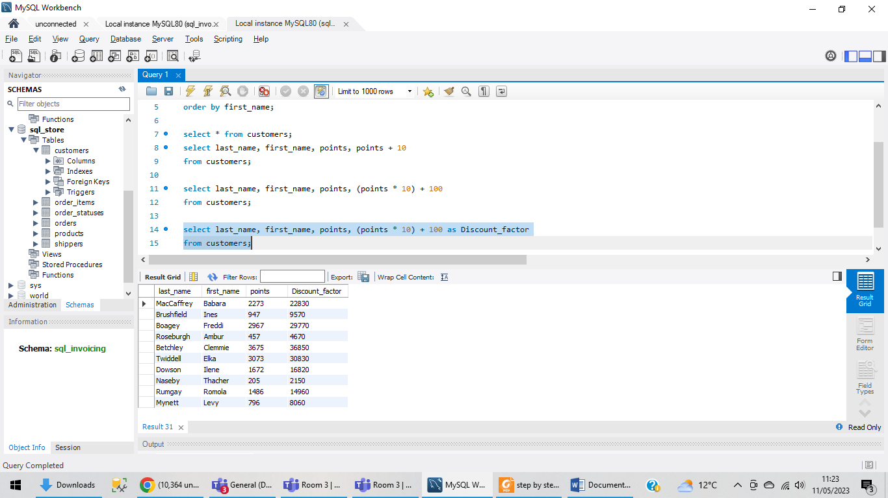

Task 2:

Write a SQL query to return all the products in our database in the result  
set. Show three columns, name, unit price, and new column called new  
price which is based on this expression, (unit price * 1.1 ).  
So what you are doing is increasing the product price of each by 10%.  
So with the query we want all the products the original price and the new  
price.

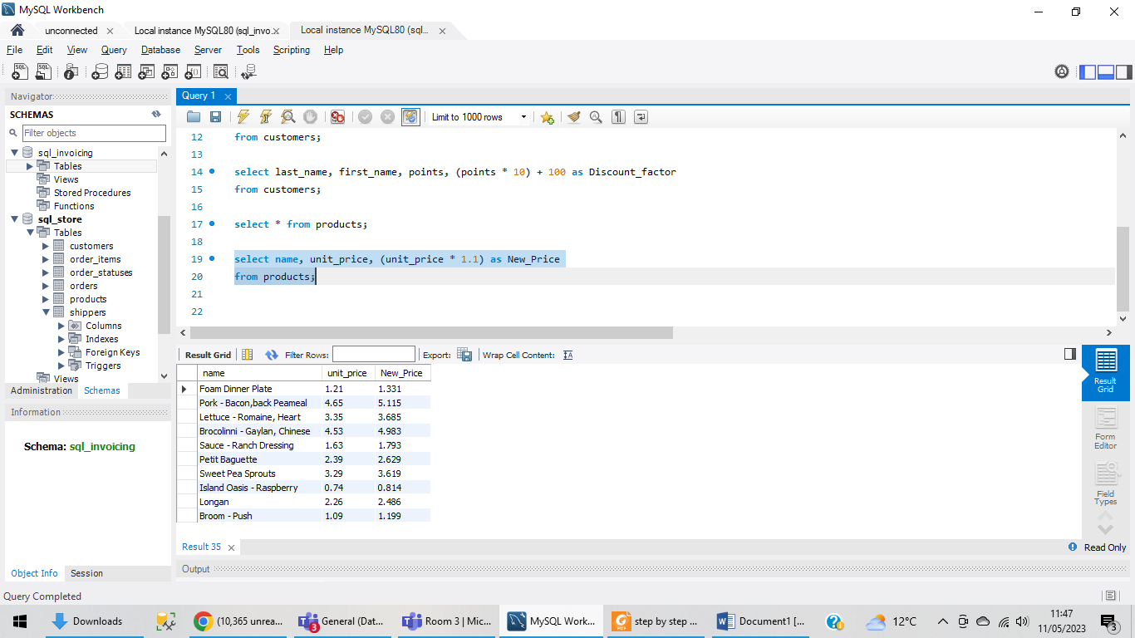

Task 3:

In this task create a new query to find all the customers with a birth date  
of > '1990-01-01'

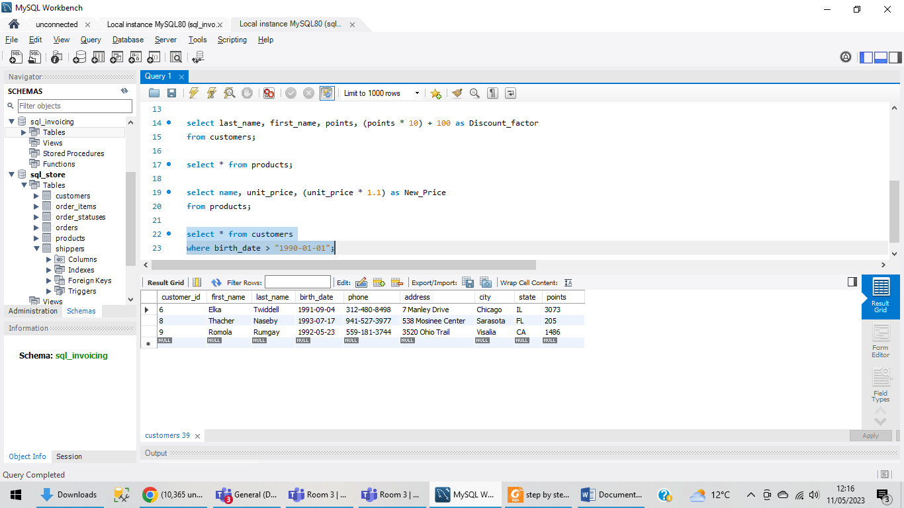

We can also be specific and only choose three columns like this:

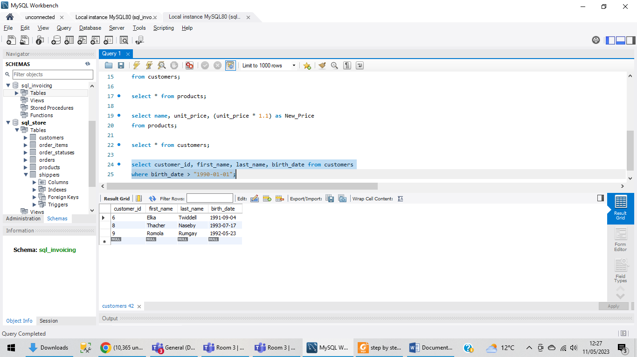

Creating an EER diagram:

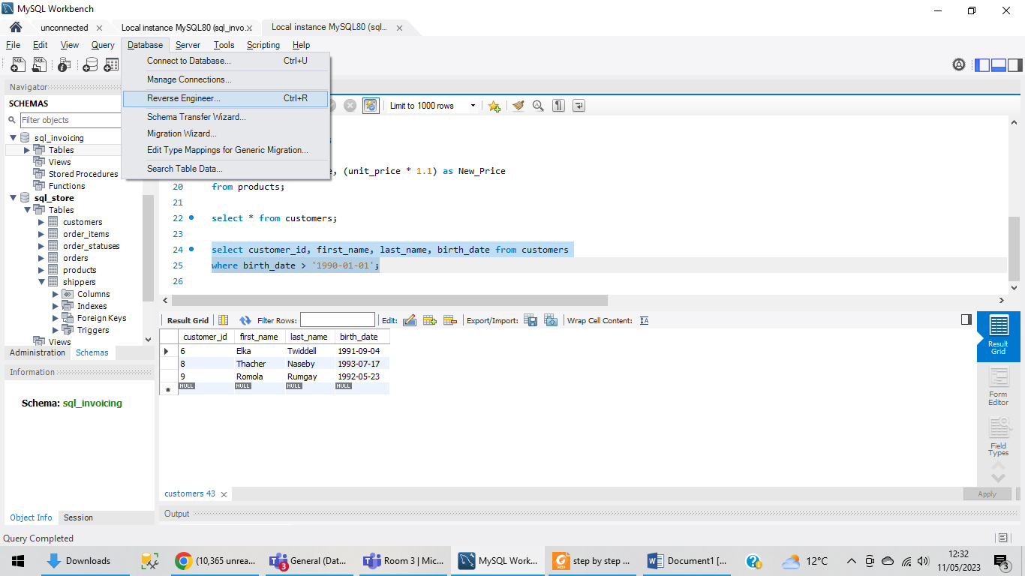

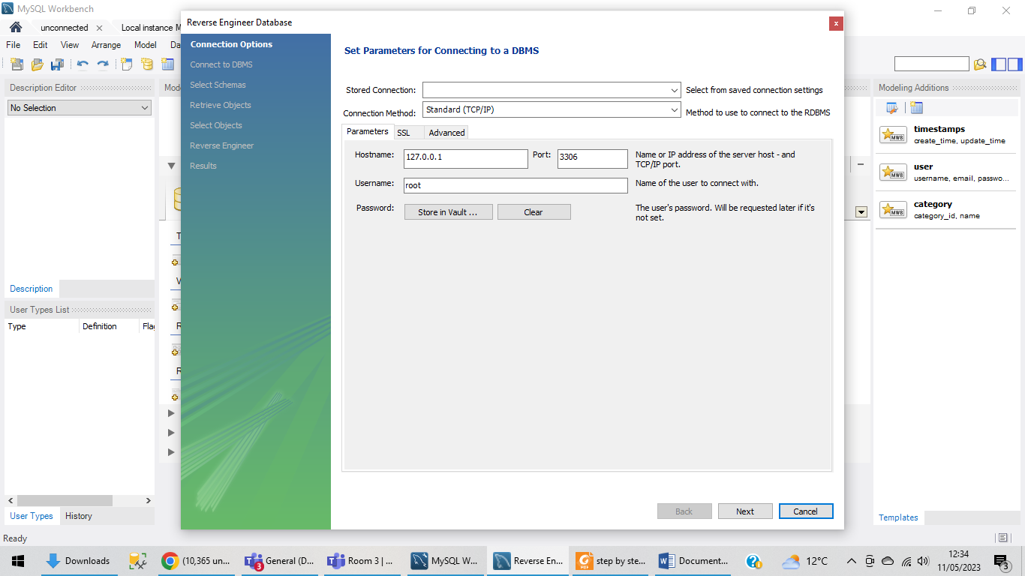

Open stored connection drop down and choose local instance and then press next:

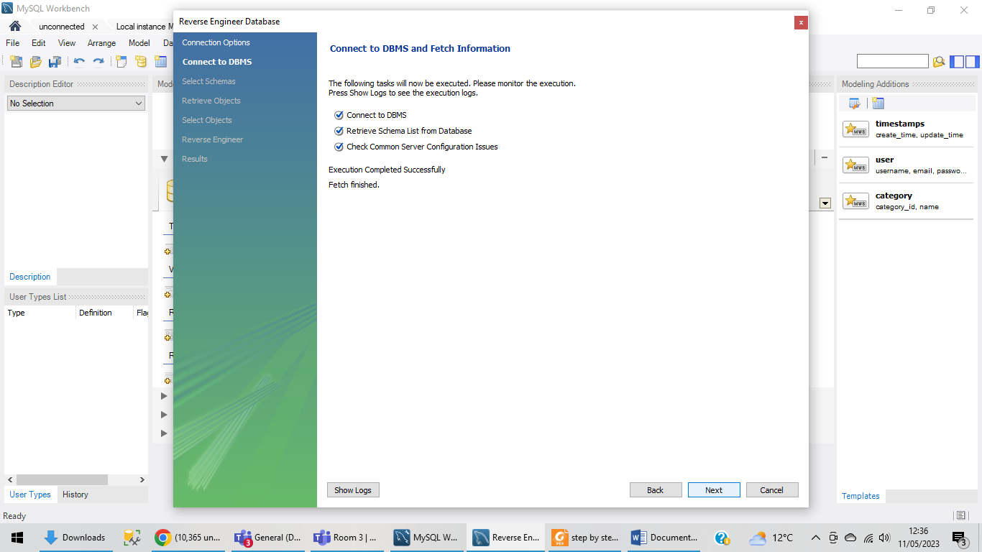

Press next and it will take you to select schemas:

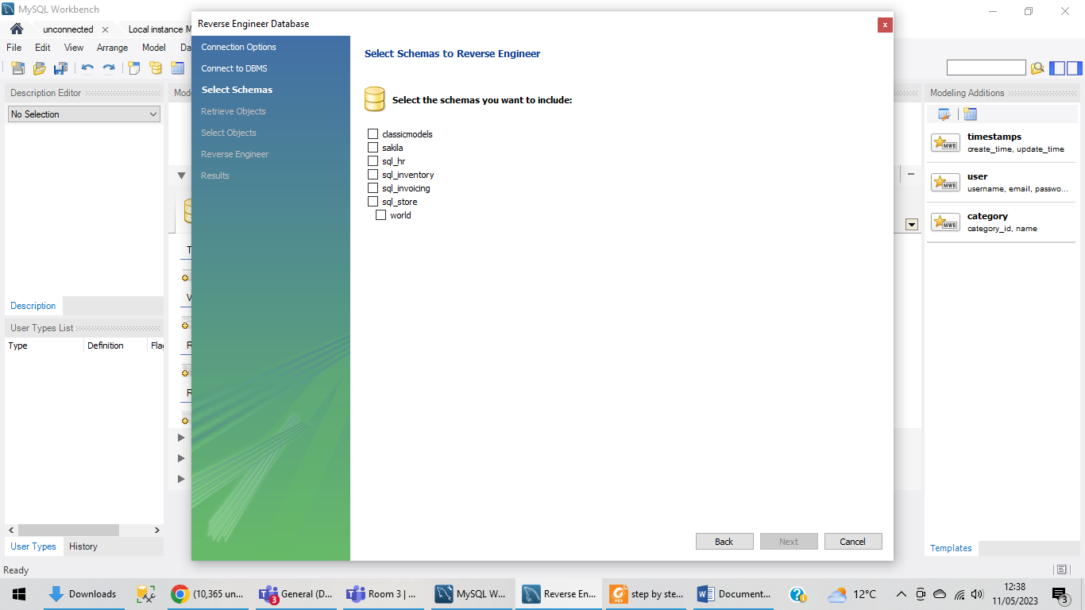

Select SQL_store:

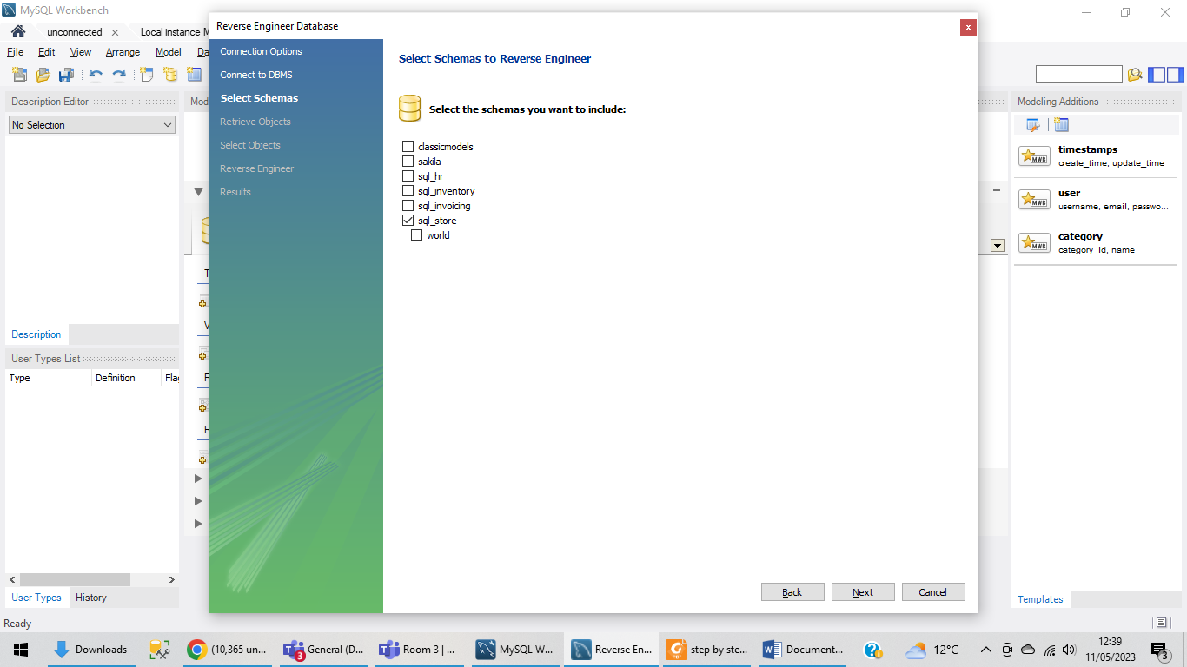

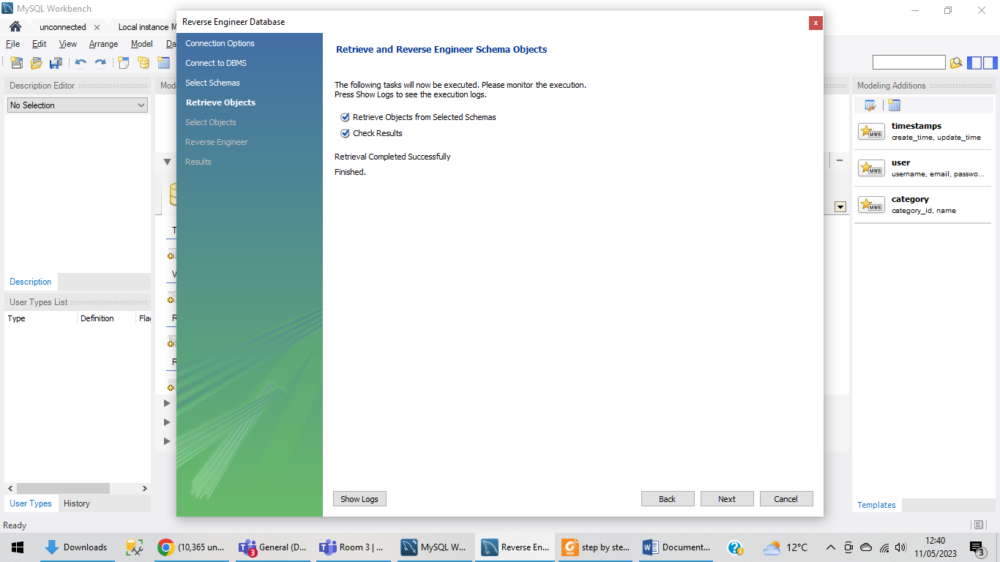

Press execute:

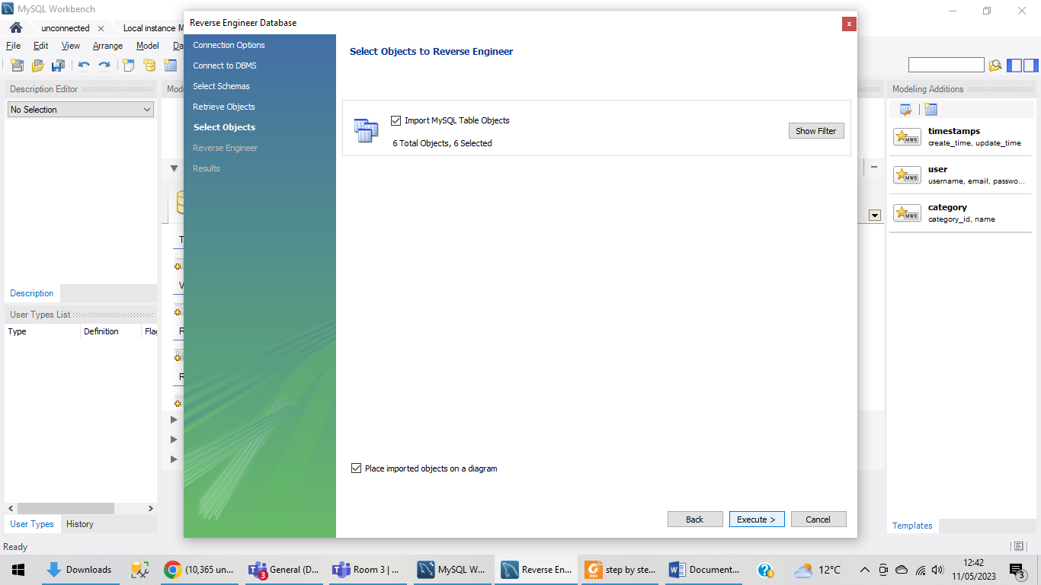

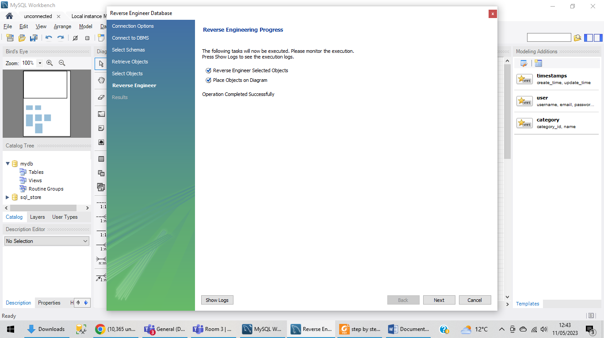

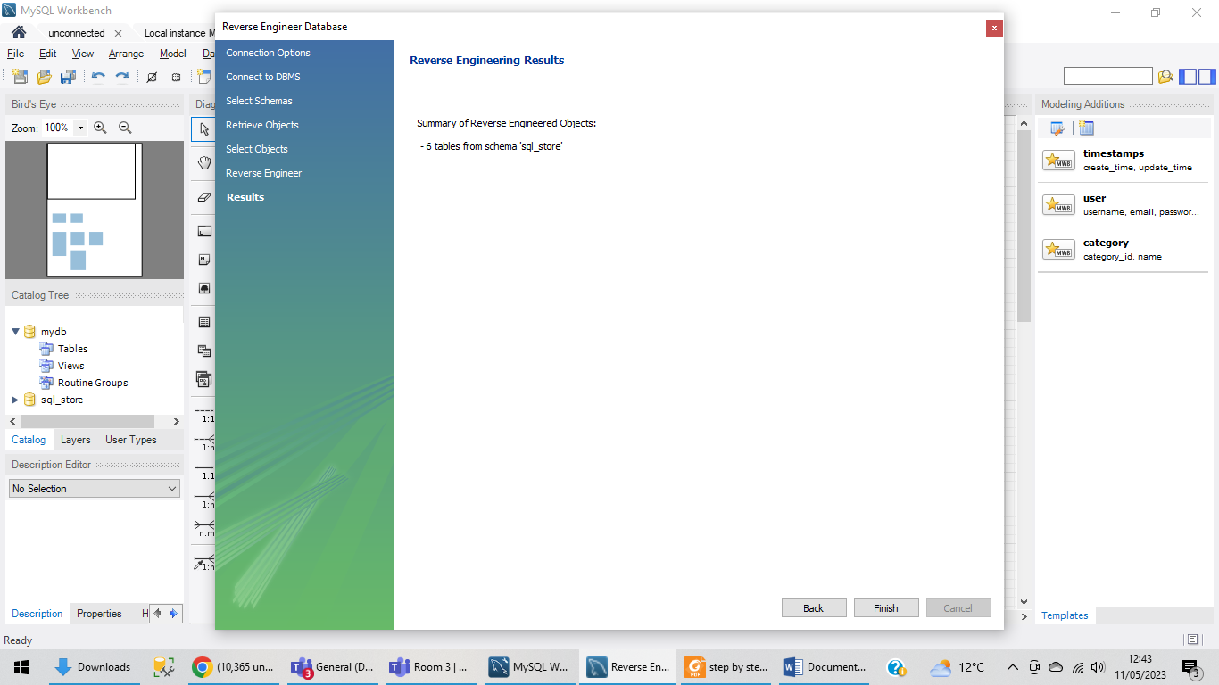

Final diagram:

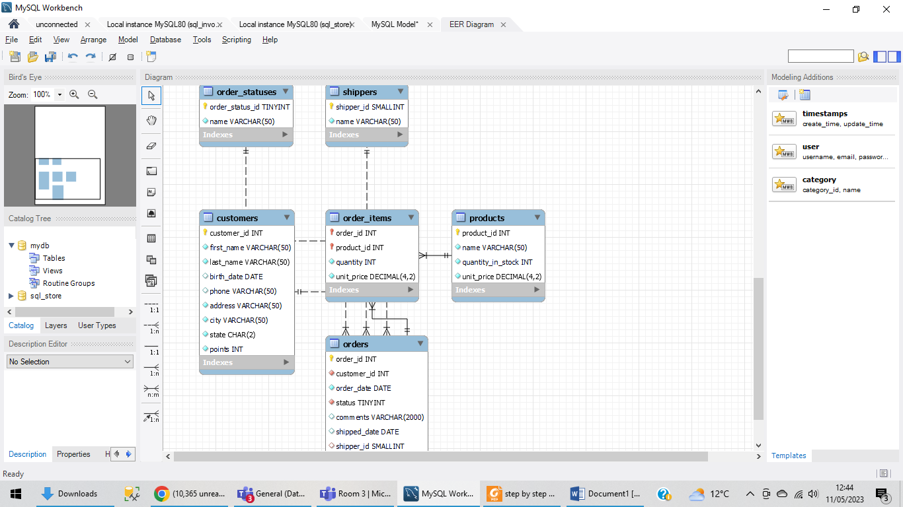

Then each team member needs to write one additional query.

## 1-Write a query to show complete record of customers where their last name starts with M?

## 2- write a query to show the customer table where the point’s column is descending?

## 3- Write a query to show records from order items where quantity is more then and equal to 3 and unit price is less than 9

## And show unit price in ascending order?

##4- Write a query to show the total sum of quantity in stock column?

##5- Write a query to show the records in orders table where comments has been given?